COA Events Flow

Account | Meaning | Type
1101 | Safeguarding / Bank Account | ASSET
2101 | Customer Wallet – Posted | LIABILITY
2102 | Customer Wallet – Pending Outgoing | LIABILITY
2103 | Customer Wallet – Pending Incoming | LIABILITY
3102 | Outgoing Payments Clearing | LIABILITY

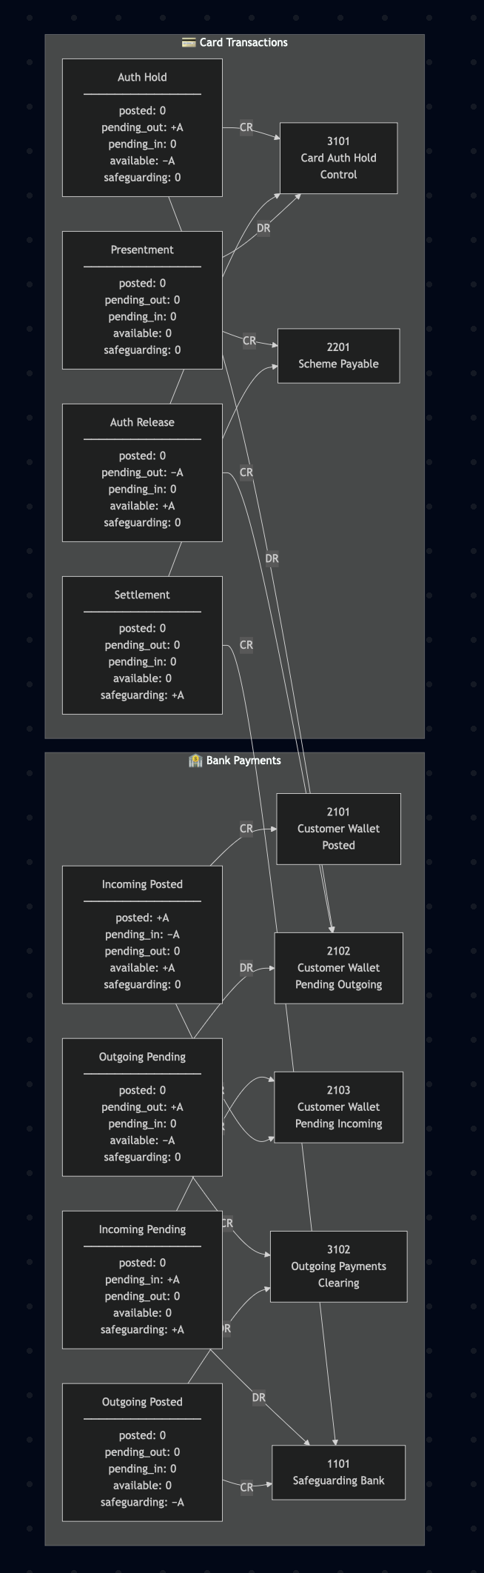

🗝️ How to read this diagram

Customer impact (availability)
- Availability ↓
  - Bank outgoing pending
  - Card auth hold
- Availability ↑
  - Auth release
  - Outgoing cancelled
  - Incoming posted
- Availability unchanged
  - Presentment
  - Settlement
  - Fees
  - Chargebacks (initially)
👉 Customer wallet is only affected at “reservation” points

Control accounts (never touch availability)
- 3101 Card auth control
- 3102 Bank outgoing clearing
These always:
- net to zero over lifecycle
- act as timing buffers
- never carry asset_id

Cash movement (real money)
- Only 1101 moves real cash
- Only at:
  - bank incoming pending
  - bank outgoing posted
  - card settlement
  - fees
This makes safeguarding reconciliation trivial.

Mental model
Availability moves when we commit to spend.
Cash moves when the bank or scheme settles.
Everything else is timing and control.

Sanity checklist for future templates
When someone adds a new template, ask:
- Does this change availability?
  - If yes → must hit 2102 or 2101
- Does this move real money?
  - If yes → must hit 1101
- Is this just a lifecycle step?
  - Then it must use a control account
If they can’t answer those three, the template isn’t ready.

Ledger Buckets

1️⃣ Objective
We want to be able to ask, at any point in time:

A. Economic solvency
Total customer wallet liabilities
= safeguarding assets + FX LP prefunded (nostro) assets ± timing

B. Regulatory safeguarding
Eligible safeguarding liabilities
≤ statutory safeguarding bank balances
The mistake to avoid is trying to make (A) and (B) use the same asset bucket.

2️⃣ First: identify the intent of COA
From the COA table, the key accounts are :

ASSETS (1000 block)
Code | Name (inferred) | Key flags
1101 | GBP Safeguarding | ASSET, is_safeguarding = true
1102 | Non-safeguarding bank / settlement | ASSET, not safeguarding
1201 | Other receivables / clearing | ASSET
1202 | Other assets | ASSET
We distinguish safeguarding vs non-safeguarding assets

LIABILITIES — Customer Wallets (2100 block)
Code | Meaning
2101 | Customer wallet – posted
2102 | Customer wallet – pending outgoing
2103 | Customer wallet – pending incoming
All require asset_id → this is the wallet layer.

LIABILITIES — Internal / Treasury (2200 + 3000 blocks)
Code | Likely role
2201 / 2202 | Settlement / scheme / processor liabilities
3101–3103, 3201 | Internal balances, accruals, suspense, etc.
These are perfect candidates for FX clearing, prefunding offsets, timing bridges.

3️⃣ The correct ledger “buckets” using COA
Now let’s define ledger buckets, not new accounts.

BUCKET 1 — Statutory Safeguarding Assets

Purpose
Regulatory, FCA-facing, bankruptcy-remote.

Accounts
1101 — Safeguarding Asset (GBP, JPY, etc.)

Rules
- Moves only when a bank safeguarding account moves
- Reconciles 1:1 to bank statements
- Used for FCA safeguarding reporting
❗ FX LP prefunding NEVER touches this bucket

BUCKET 2 — Customer-Backing, Non-Safeguarded Assets (LP Nostro)

Purpose
Economic backing of wallets, liquidity, FX execution.

Accounts
1102 — Non-safeguarding bank / settlement / nostro
1201 — FX receivable / clearing (if needed)
This is where prefunded LP balances live.

Examples
- Convera prefunded GBP balance
- JPY nostro held at LP
- Margin / collateral accounts

Rules
- Included in economic reconciliation
- Excluded from safeguarding reports
- Reconciles to LP statements, not banks

BUCKET 3 — Customer Wallet Liabilities

Purpose
What we owe customers.

Accounts
2101 — Customer wallet (posted)
2102 — Customer wallet (pending out)
2103 — Customer wallet (pending in)

Rules
- Always reconcile to (Bucket 1 + Bucket 2)
- Never reconciled directly to banks

BUCKET 4 — FX Clearing / Prefunding Bridges
This is the missing conceptual piece that avoids recon breaks.

Accounts
1201 — FX clearing (asset, temporary)
31xx / 32xx — Internal FX clearing liabilities

Purpose
- Temporarily hold value between wallet movement and real money movement
- Decouple customer actions from bank timing

4️⃣ Concrete example

Scenario
- Customer has £100 in GBP wallet
- LP requires prefunding
- No safeguarding bank movement yet

Step 1 — Customer initiates FX
Dr 2101 Customer GBP Wallet £100
Cr 31xx FX Conversion Clearing £100
✅ No safeguarding touched
✅ No bank movement implied

Step 2 — FX executed using LP prefunding
LP uses already prefunded GBP and credits JPY.
Dr 1102 LP Nostro JPY ¥20,000
Cr 31xx FX Conversion Clearing £100 (GBP-equivalent)

Step 3 — Credit customer JPY wallet
Dr 31xx FX Conversion Clearing ¥20,000
Cr 2101 Customer JPY Wallet ¥20,000

Resulting state

Assets
1101 Safeguarding (bank) unchanged
1102 LP Nostro adjusted

Liabilities
2101 Wallets updated
✔️ Economic backing preserved
✔️ Safeguarding untouched
✔️ Recon clean

5️⃣ Reconciliation formulas

Internal treasury recon (daily)
SUM(2101 + 2102 + 2103)
=
SUM(1101) + SUM(1102) + timing

Safeguarding recon (regulatory)
Eligible safeguarding liabilities
≤
SUM(1101 only)

6️⃣ Elevate COA rule
Safeguarding only moves with banks
LP prefunding lives in non-safeguarded assets

7️⃣ One-sentence auditor explanation
“Customer balances are economically backed by a combination of statutory safeguarding accounts and prefunded liquidity accounts held with FX providers. Only the former are treated as safeguarding assets for regulatory purposes.”

